GOODS ISSUE BINYAH

Home - Personal - Microsoft​ Edge
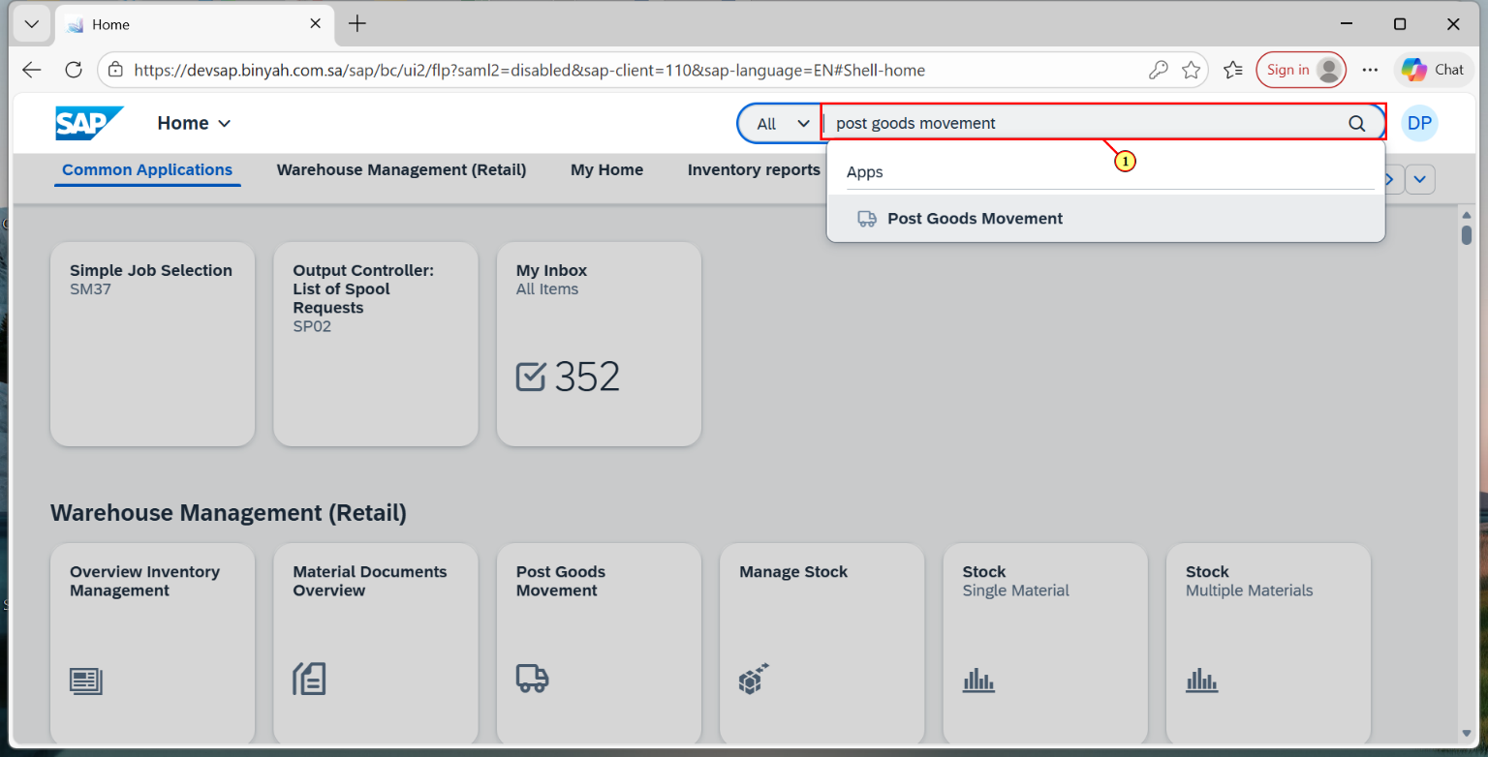
Step | Action
(1) | Search and Open "Post Goods Movement".

Goods Issue Other - Personal - Microsoft​ Edge
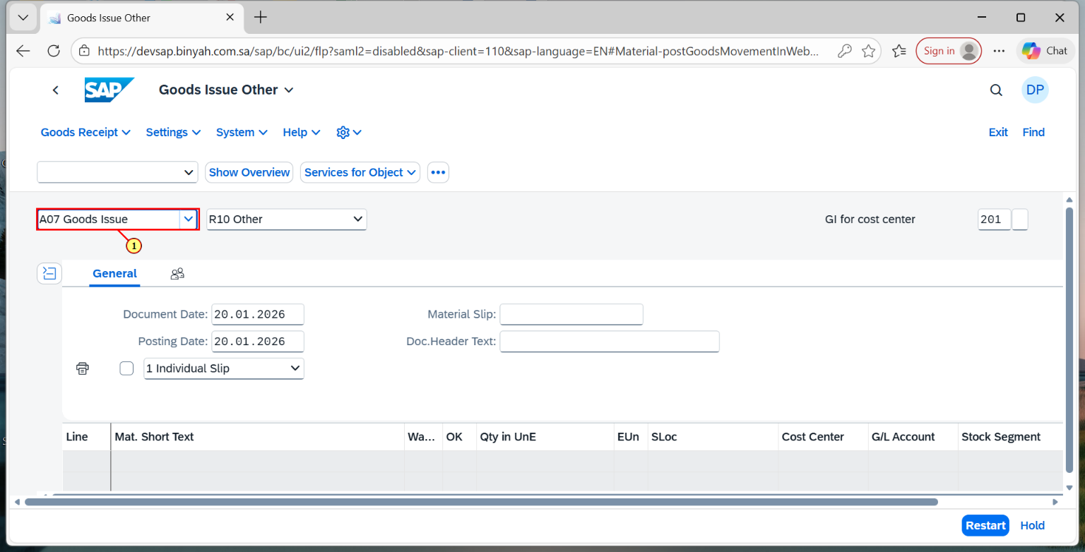
Step | Action
(1) | Select "Goods Issue".

Goods Issue Other - Personal - Microsoft​ Edge
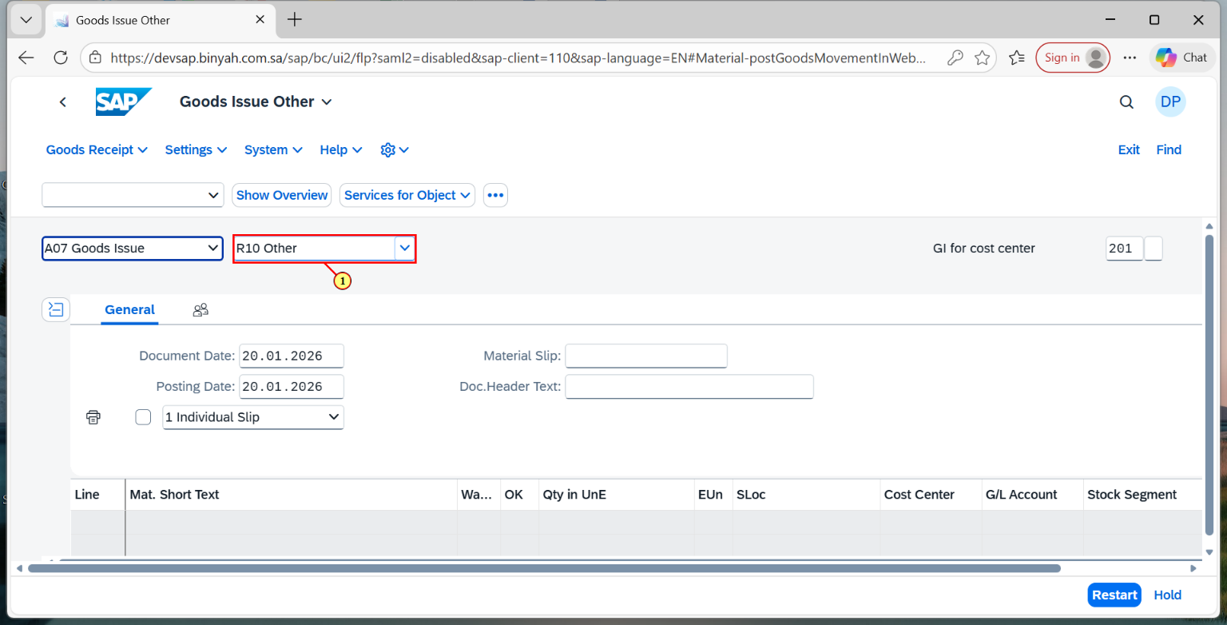
Step | Action
(1) | Select "Other".

Goods Issue Other - Personal - Microsoft​ Edge
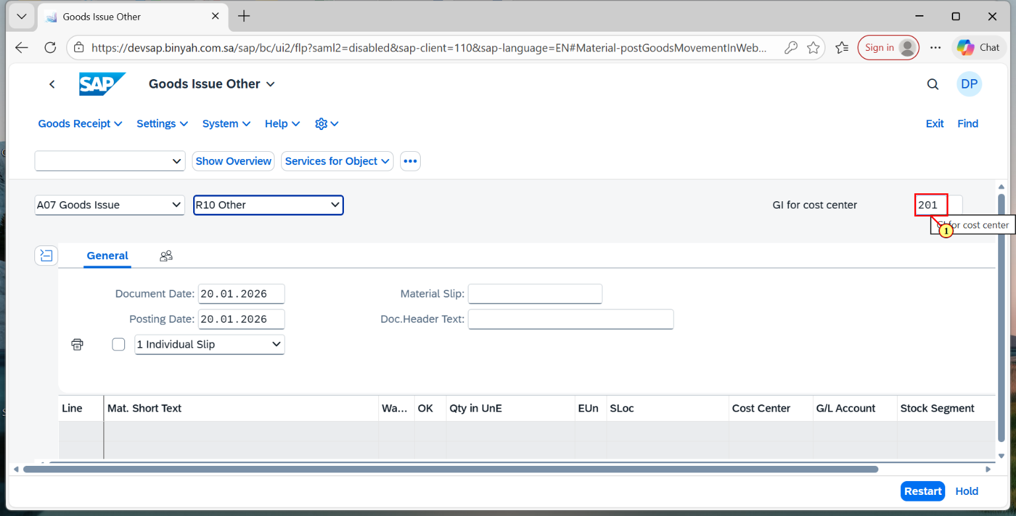
Step | Action
(1) | Verify if the movement type is "201".

Goods Issue Other - Personal - Microsoft​ Edge
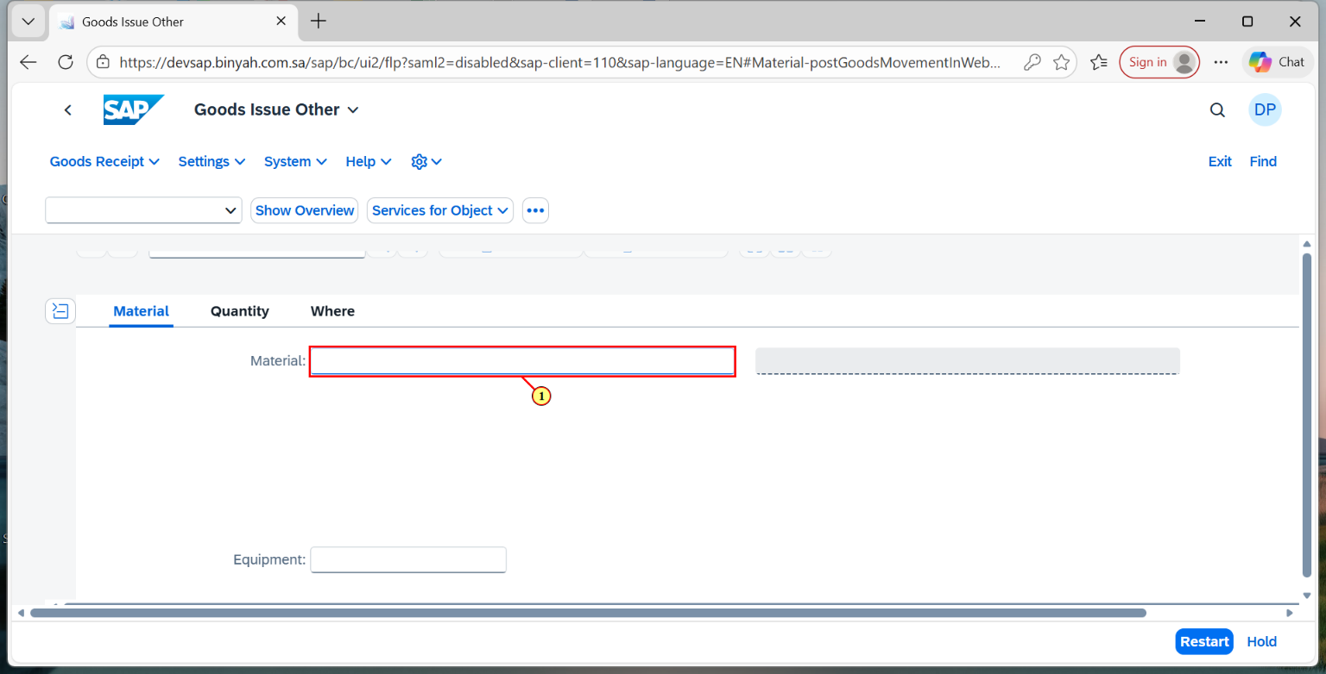
Step | Action
(1) | Enter "Material".

Goods Issue Other - Personal - Microsoft​ Edge
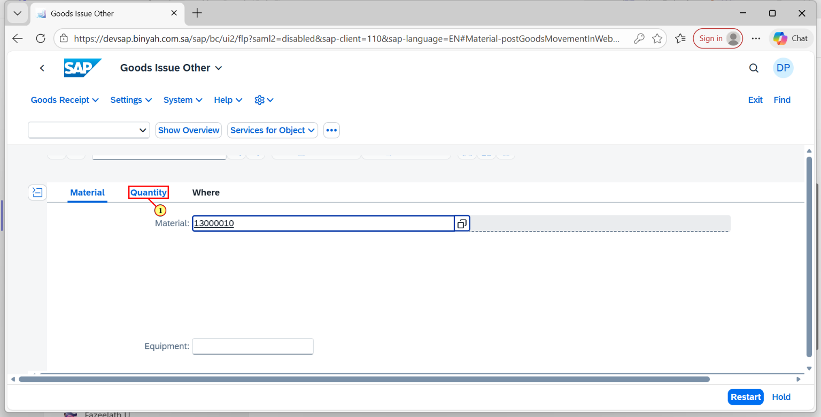
Step | Action
(1) | Click on Quantity Tab.

Goods Issue Other - Personal - Microsoft​ Edge
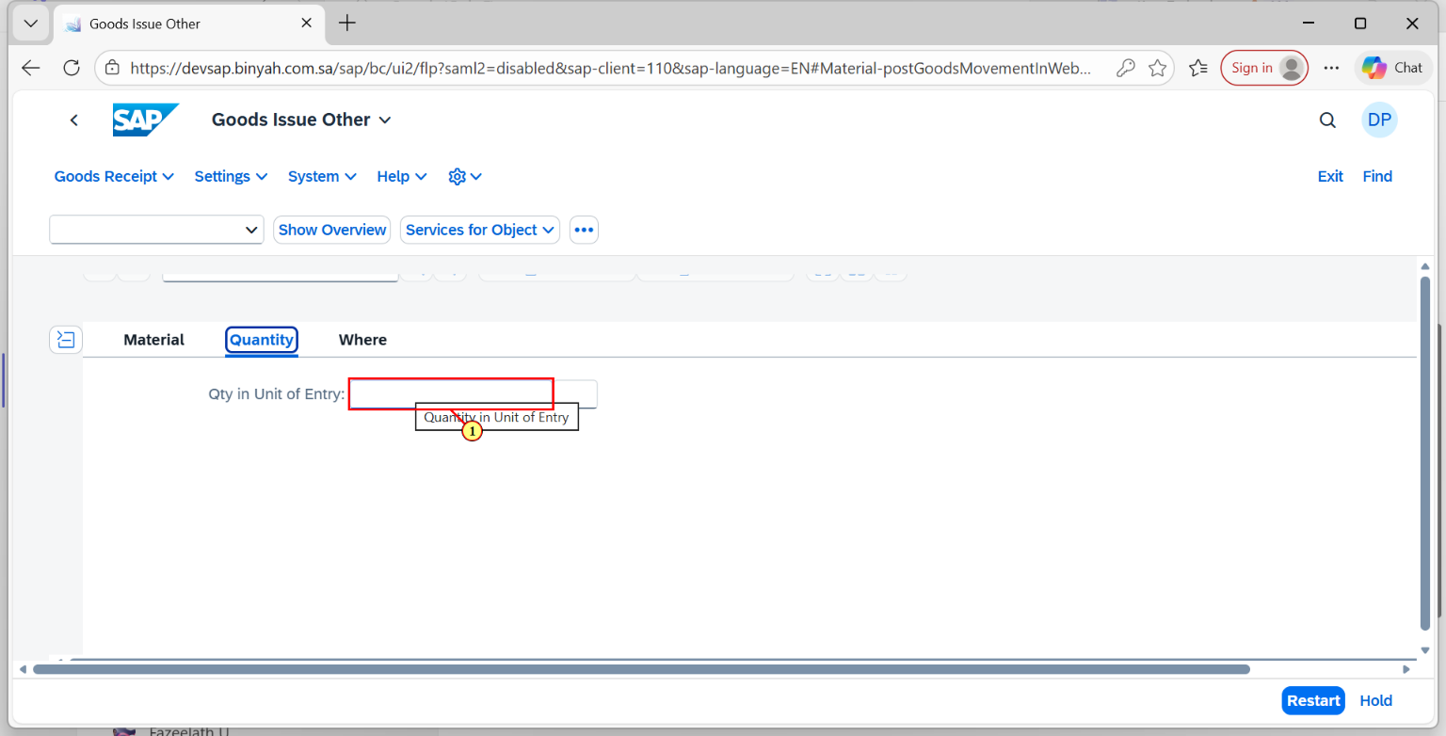
Step | Action
(1) | Enter "Quantity".

Goods Issue Other - Personal - Microsoft​ Edge
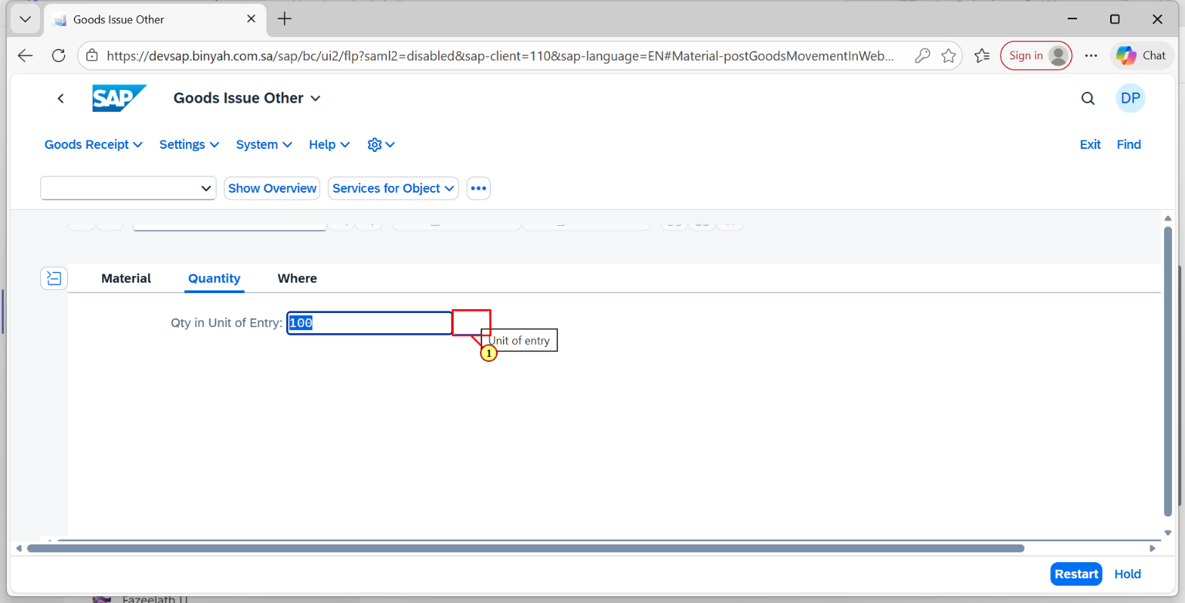
Step | Action
(1) | Enter "Unit of Measure".

Goods Issue Other - Personal - Microsoft​ Edge
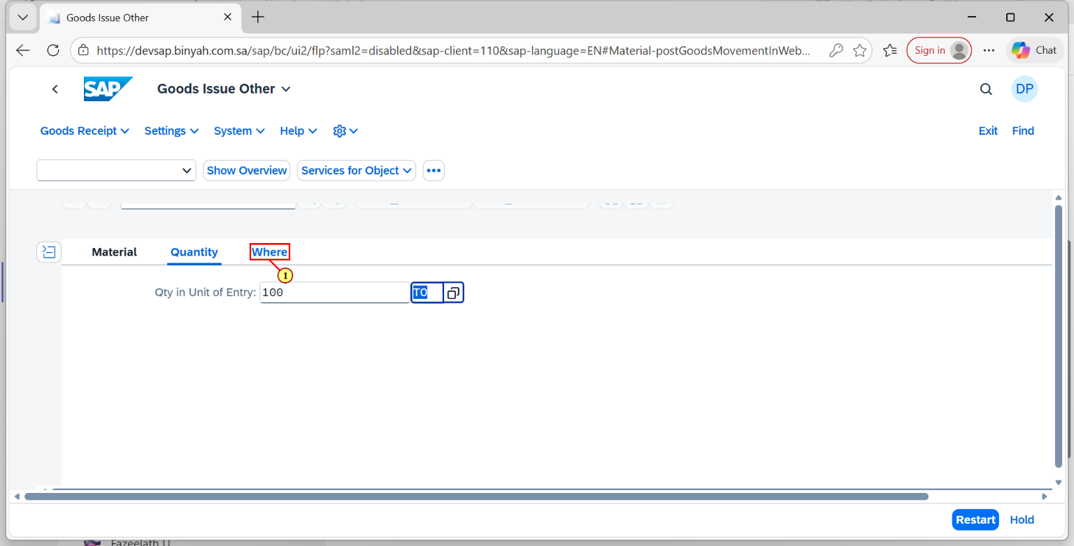
Step | Action
(1) | Click on "Where Tab".

Goods Issue Other - Personal - Microsoft​ Edge
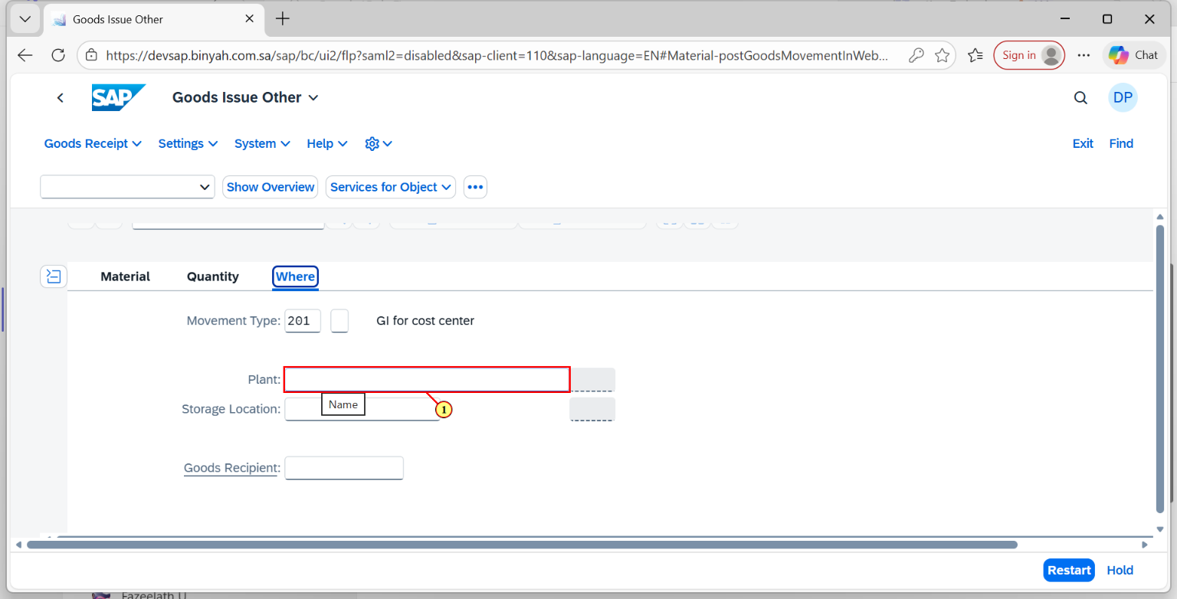
Step | Action
(1) | Enter "Plant".

Goods Issue Other - Personal - Microsoft​ Edge
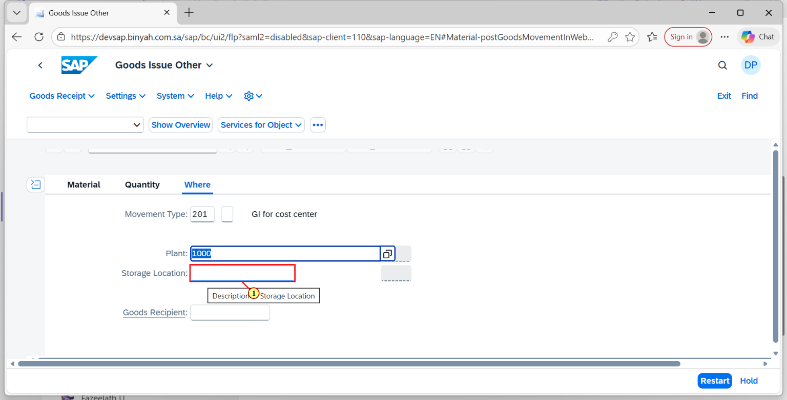
Step | Action
(1) | Enter "Storage Location".

Goods Issue Other - Personal - Microsoft​ Edge
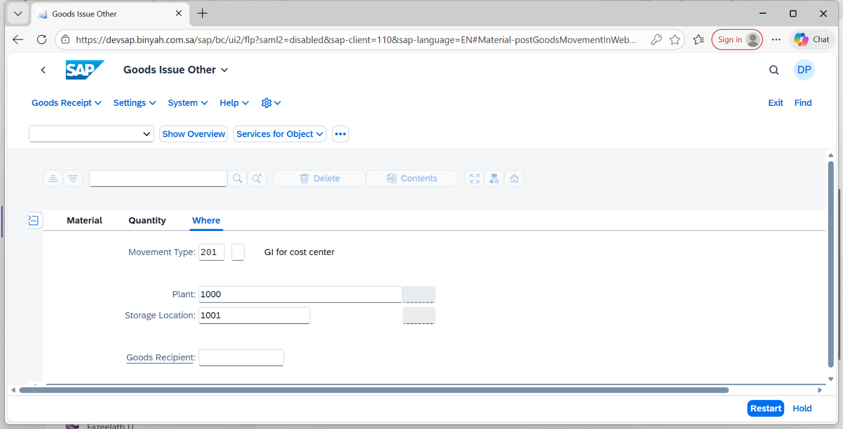
Step | Action
 | Click "Enter".

Goods Issue Other - Personal - Microsoft​ Edge
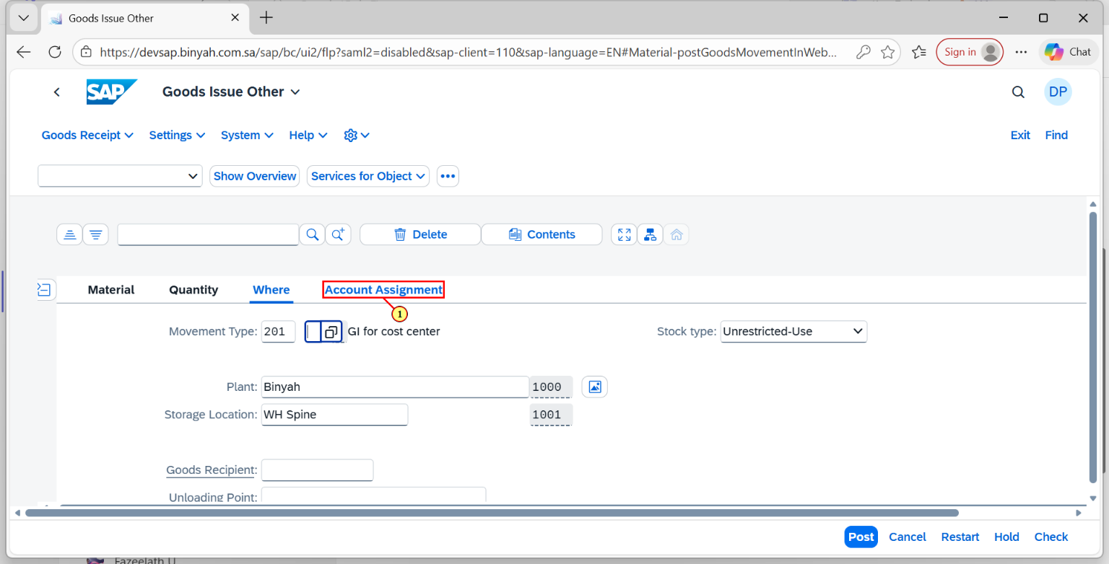
Step | Action
(1) | Select Account Assignment Tab.

Goods Issue Other - Personal - Microsoft​ Edge
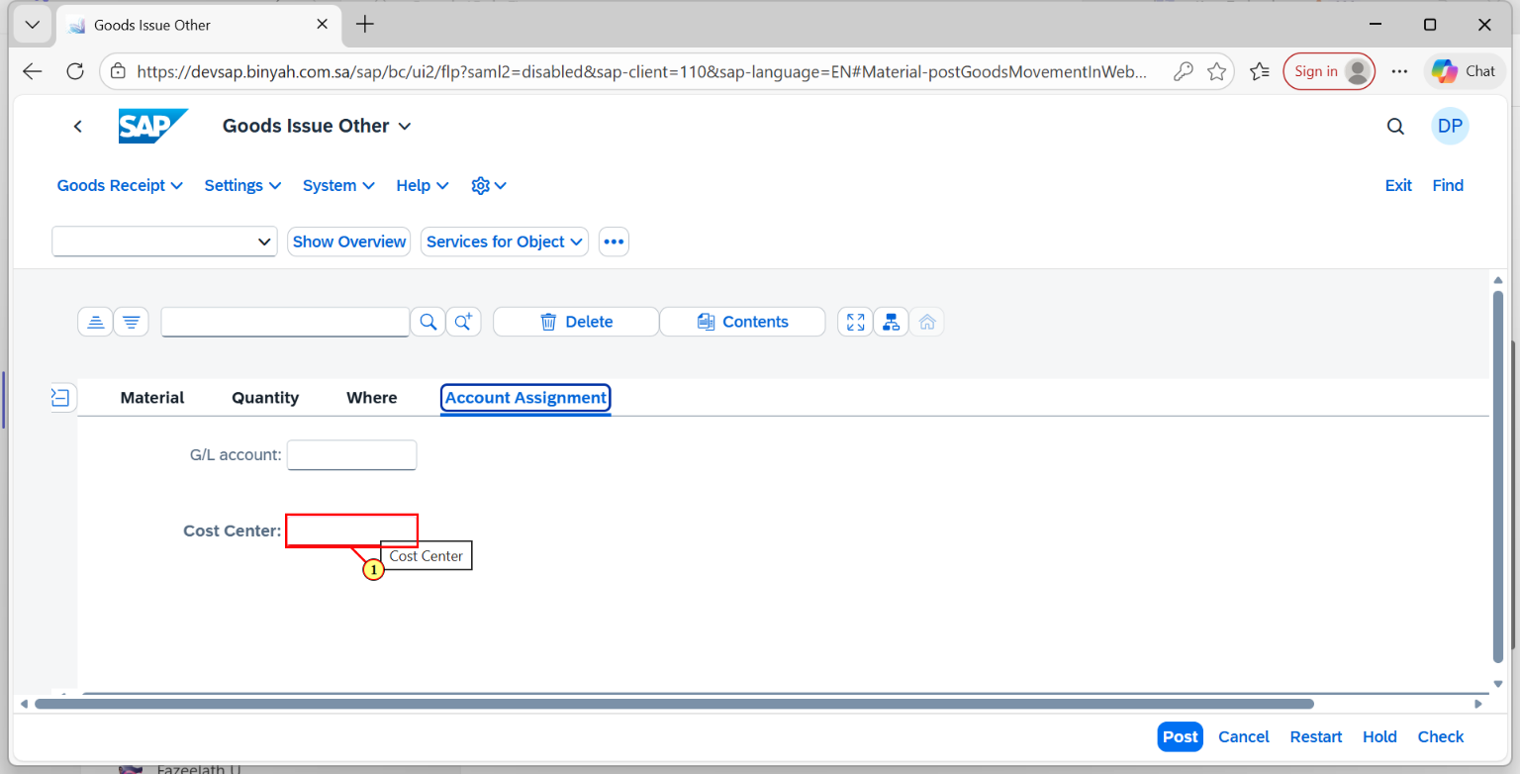
Step | Action
(1) | Enter the "Cost Center".

Goods Issue Other - Personal - Microsoft​ Edge
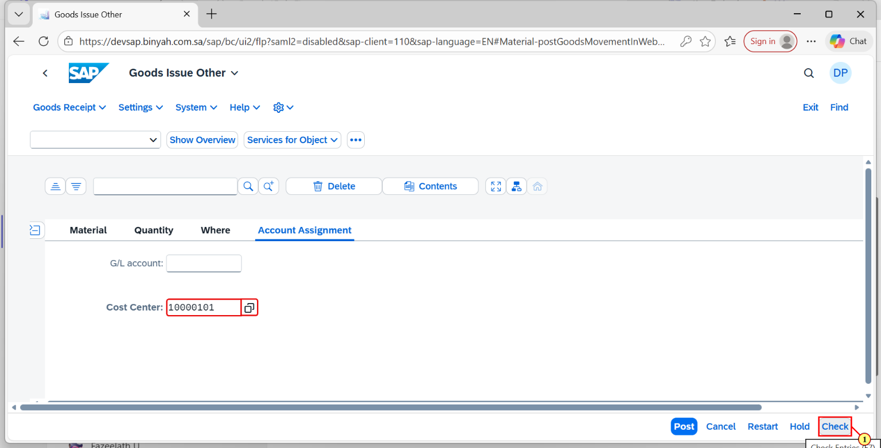
Step | Action
(1) | Click "Check" Button.

Goods Issue Other - Personal - Microsoft​ Edge
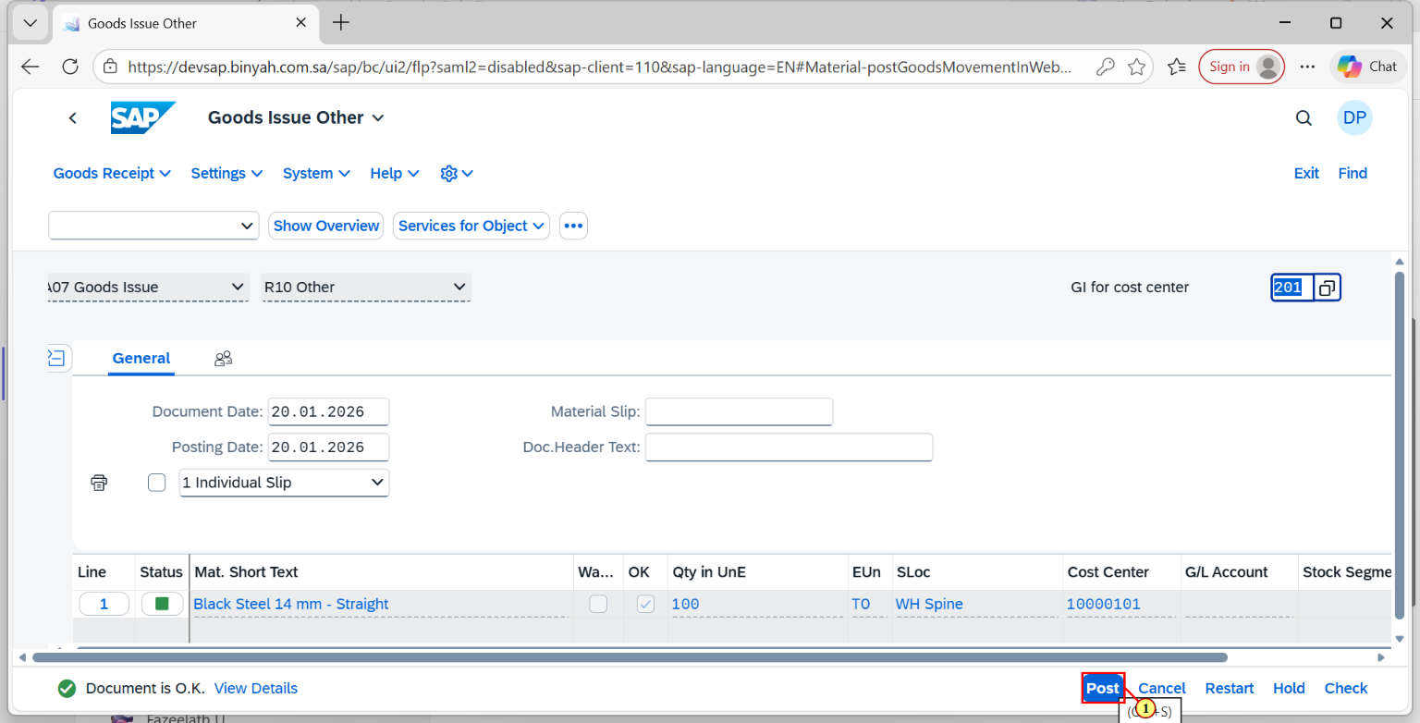
Step | Action
(1) | Click on "Post".

Goods Issue Other - Personal - Microsoft​ Edge
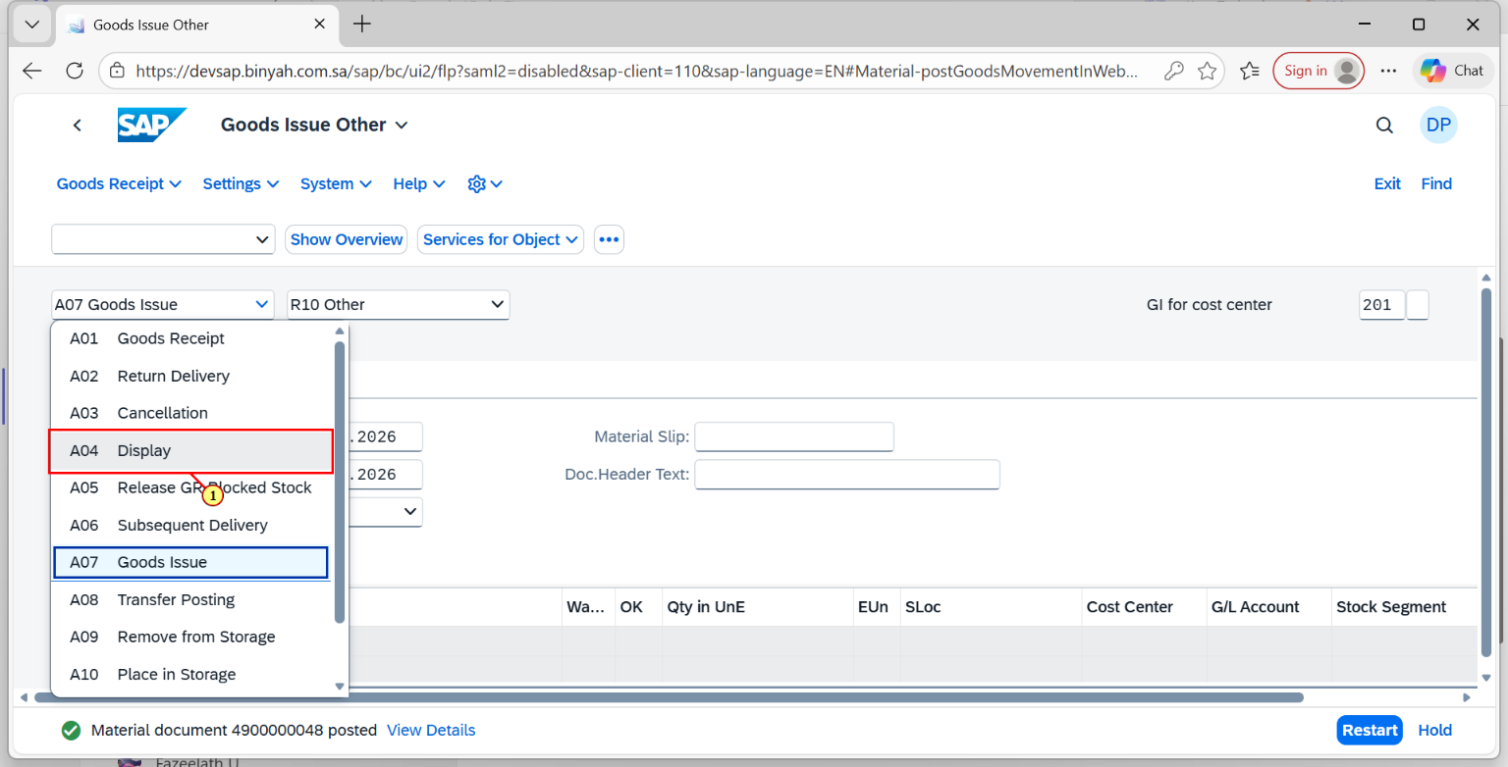
Step | Action
(1) | To View the Material Document, Again select "Display".

Display Material Document - Personal - Microsoft​ Edge
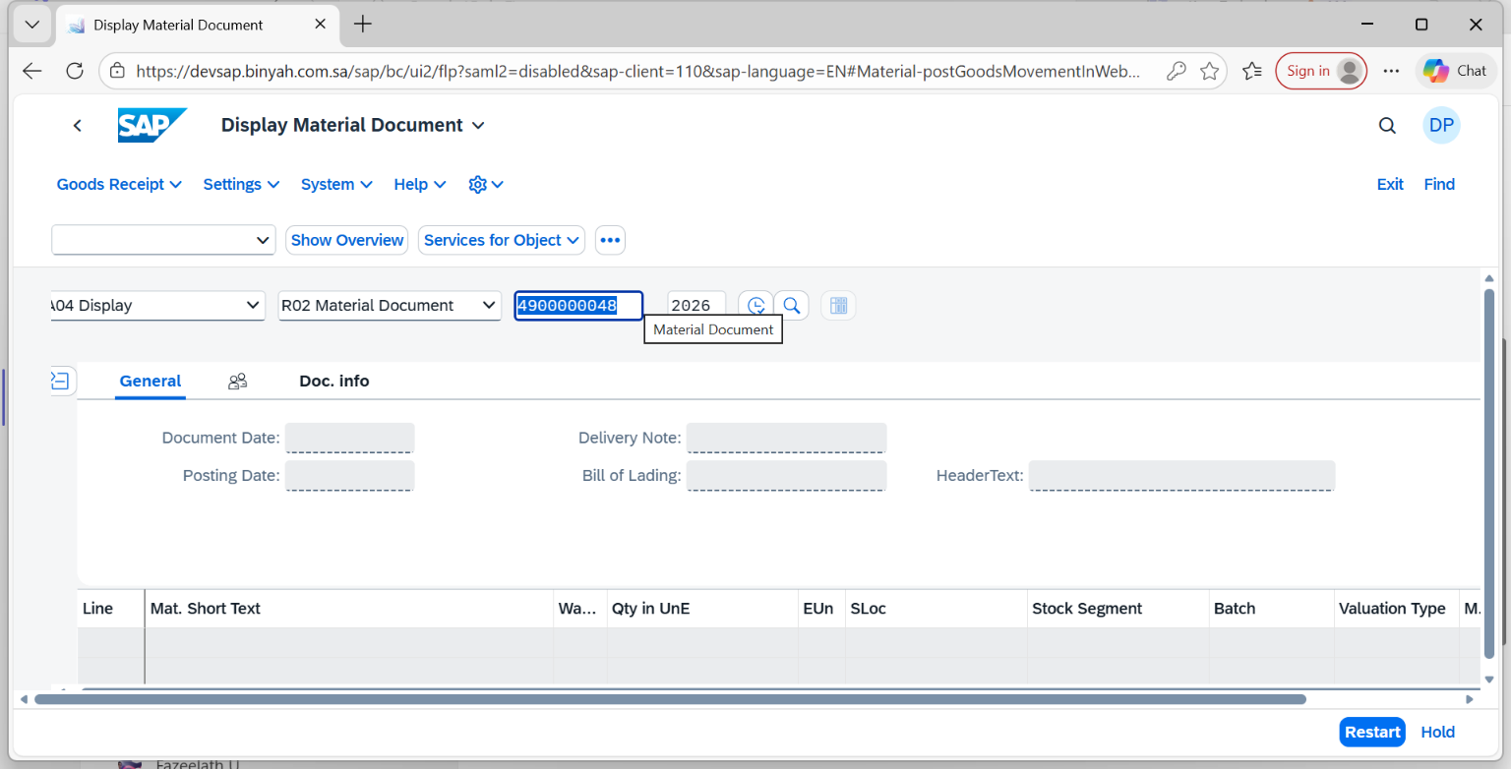
Step | Action
 | After the Header is filled press "Enter".

Display Material Document 4900000048 - Personal - Microsoft​ Edge
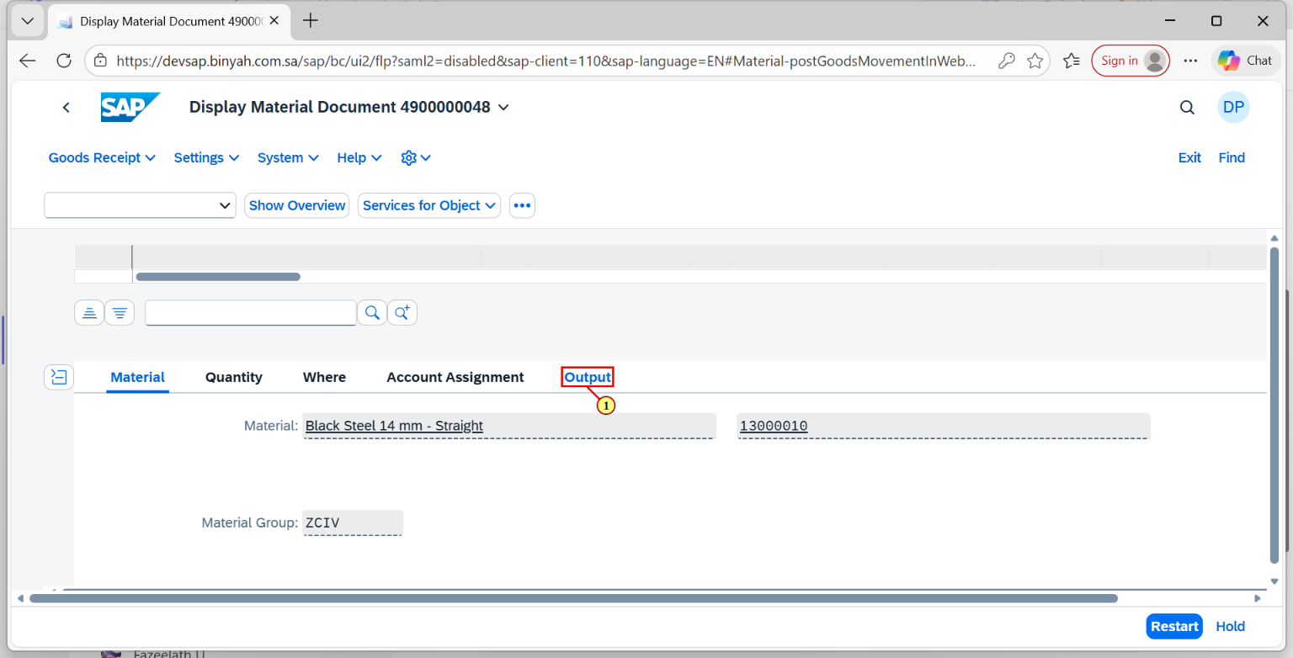
Step | Action
(1) | Click on Output Tab.

Display Material Document 4900000048 - Personal - Microsoft​ Edge
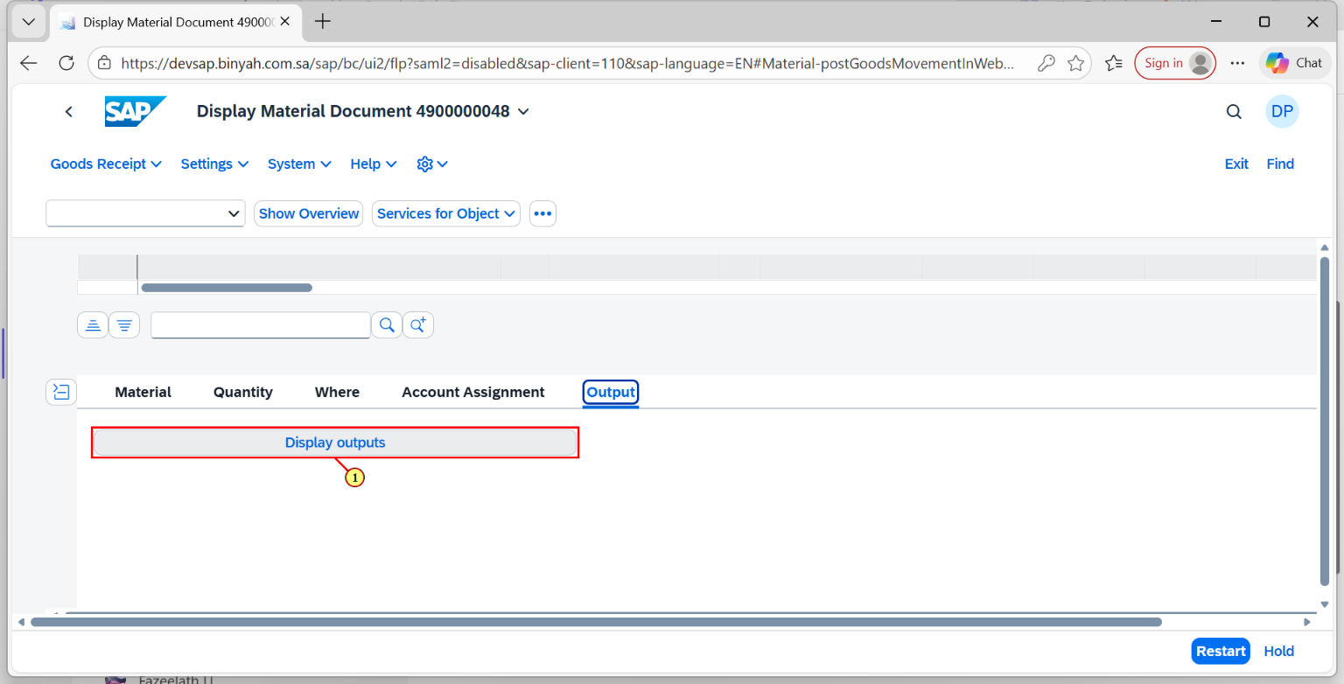
Step | Action
(1) | Clik on "Display Outputs".

Material Doc.: Output - Personal - Microsoft​ Edge
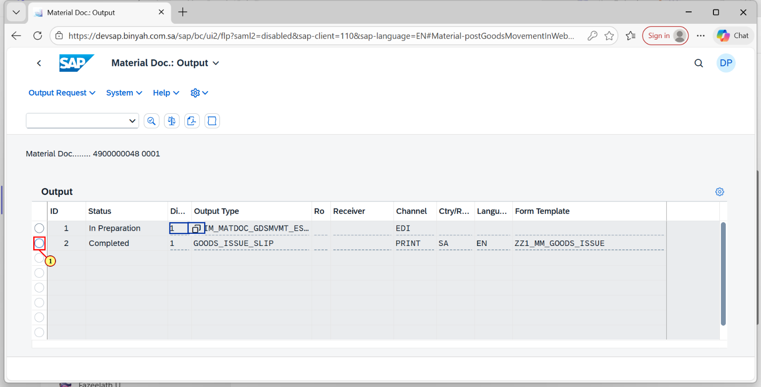
Step | Action
(1) | Select the "Document".

Material Doc.: Output - Personal - Microsoft​ Edge
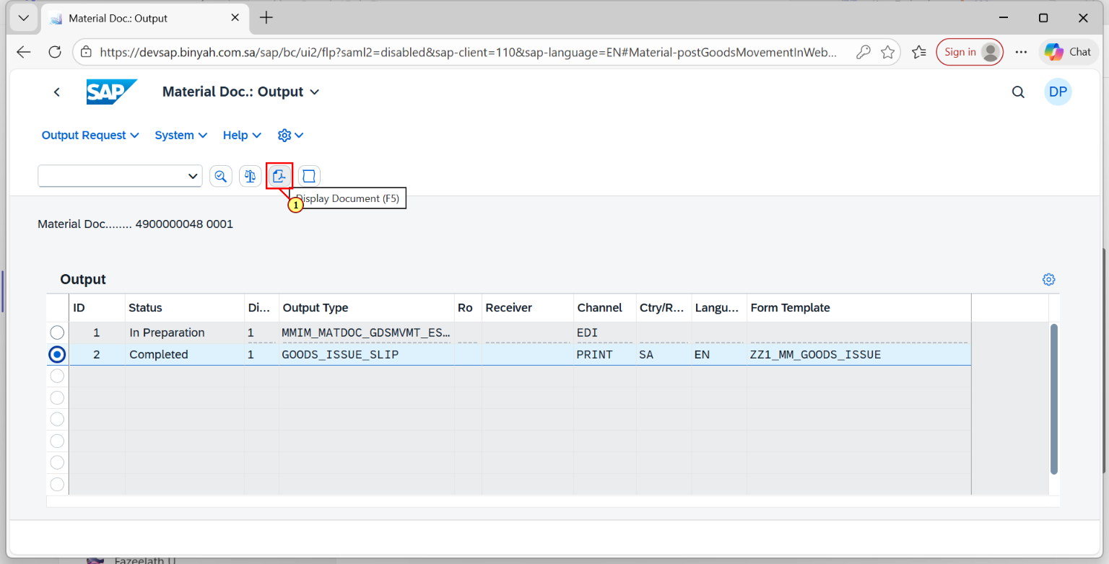
Step | Action
(1) | Click on "PDF Icon" to view the Material Document.

Material Doc.: Output - Personal - Microsoft​ Edge
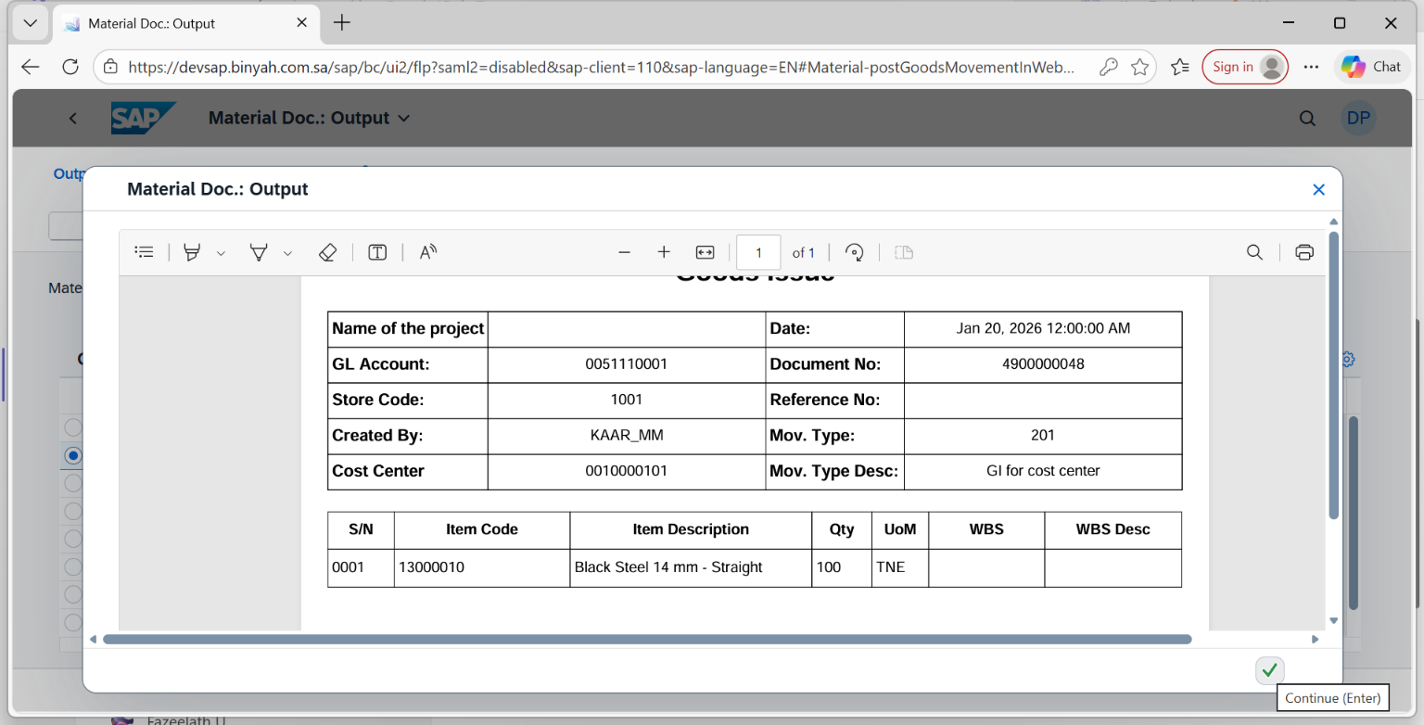
Step | Action
(1) | The Material Document is Displayed.

